ECE 278A

KLT, DCT, DFT Image compression/Reconstruction Report

Yifan Lu

Set 1

|  |  |  |  |  |
| --- | --- | --- | --- | --- |
|  | RMSE  (5 Coef) | RMSE  (10 Coef) | RMSE  (20 Coef) | RMSE  (100 Coef) |
| KLT | 0.1103 | 0.0741 | 0 | N/A (0) |
| DFT | 0.1409 | 0.1289 | 0.1186 | 0.0955 |
| DCT | 0.1597 | 0.1558 | 0.1520 | 0.1446 |

Set 2

|  |  |  |  |  |
| --- | --- | --- | --- | --- |
|  | RMSE  (5 Coef) | RMSE  (10 Coef) | RMSE  (20 Coef) | RMSE  (100 Coef) |
| KLT | 0.2621 | 0.2741 | 0.2843 | N/A (0.2843) |
| DFT | 0.1521 | 0.1373 | 0.1246 | 0.0974 |
| DCT | 0.1705 | 0.1656 | 0.1611 | 0.1526 |

KLT with 5 coefficients on Set1:

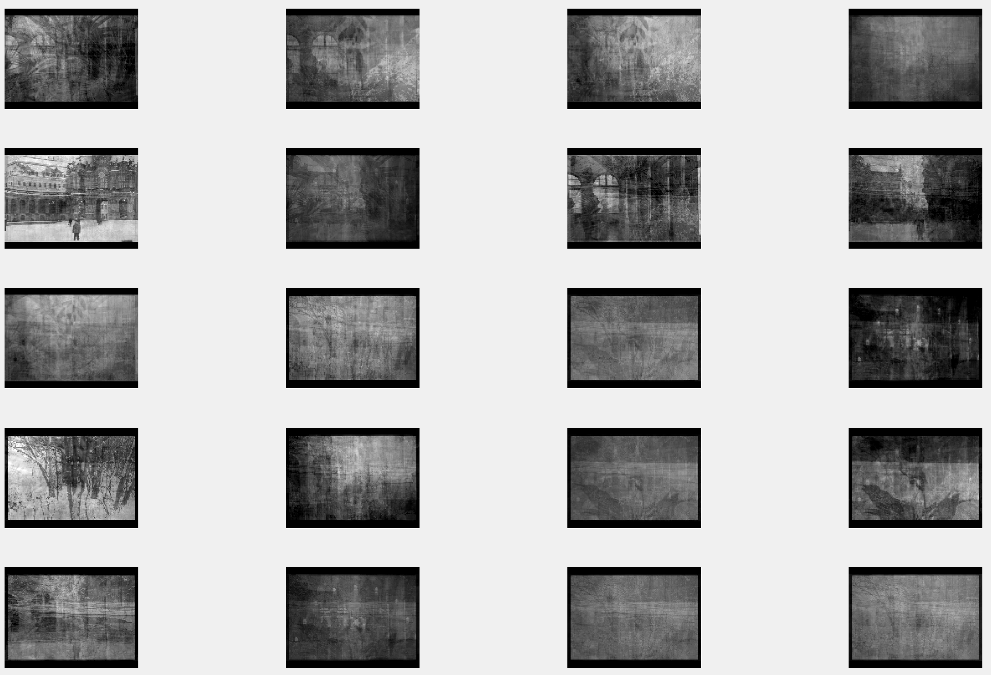

KLT with 5 coefficients on Set2:

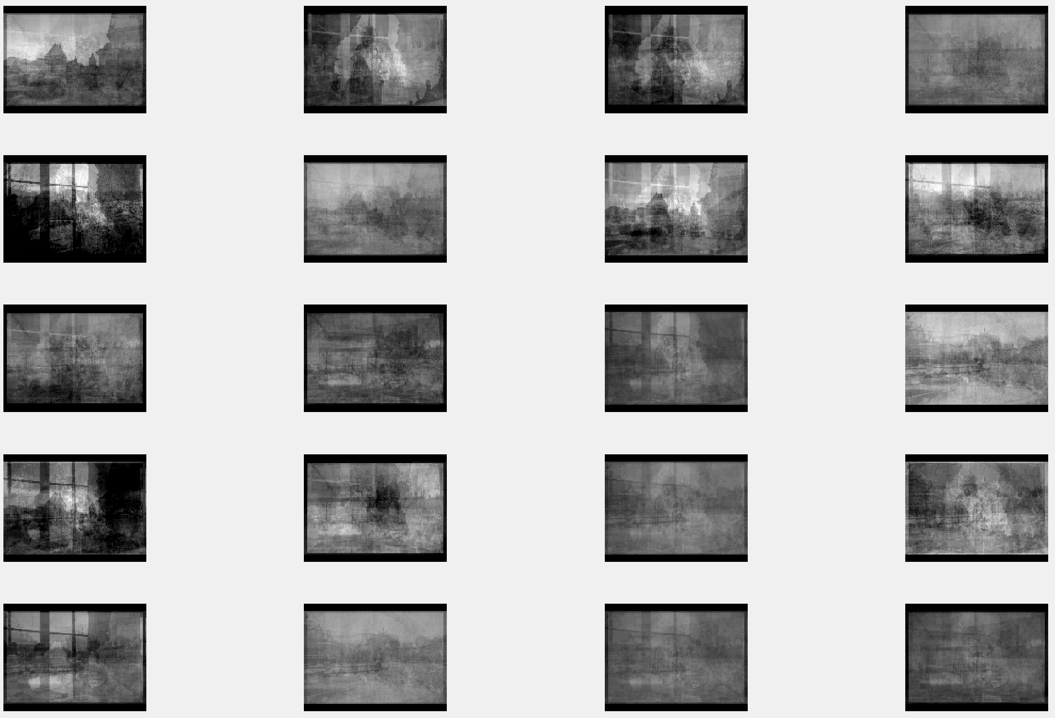

KLT with 10 coefficients on Set1:

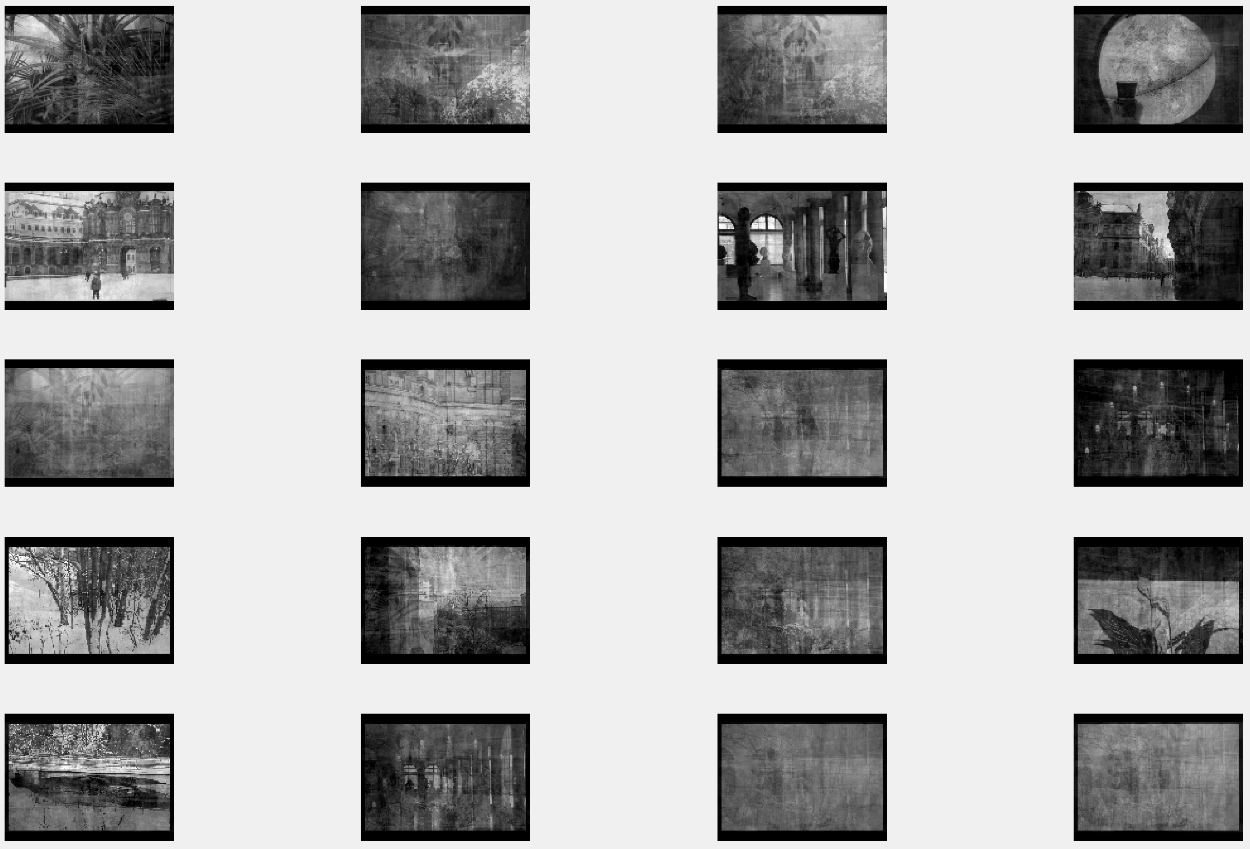

KLT with 10 coefficients on Set2:

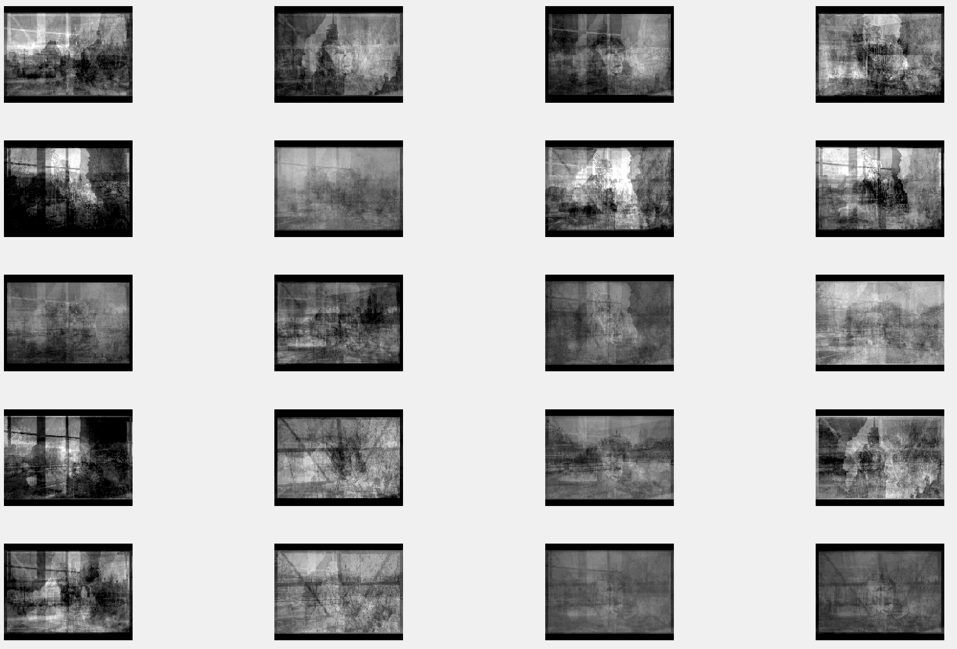

KLT with 20 coefficients on Set1:

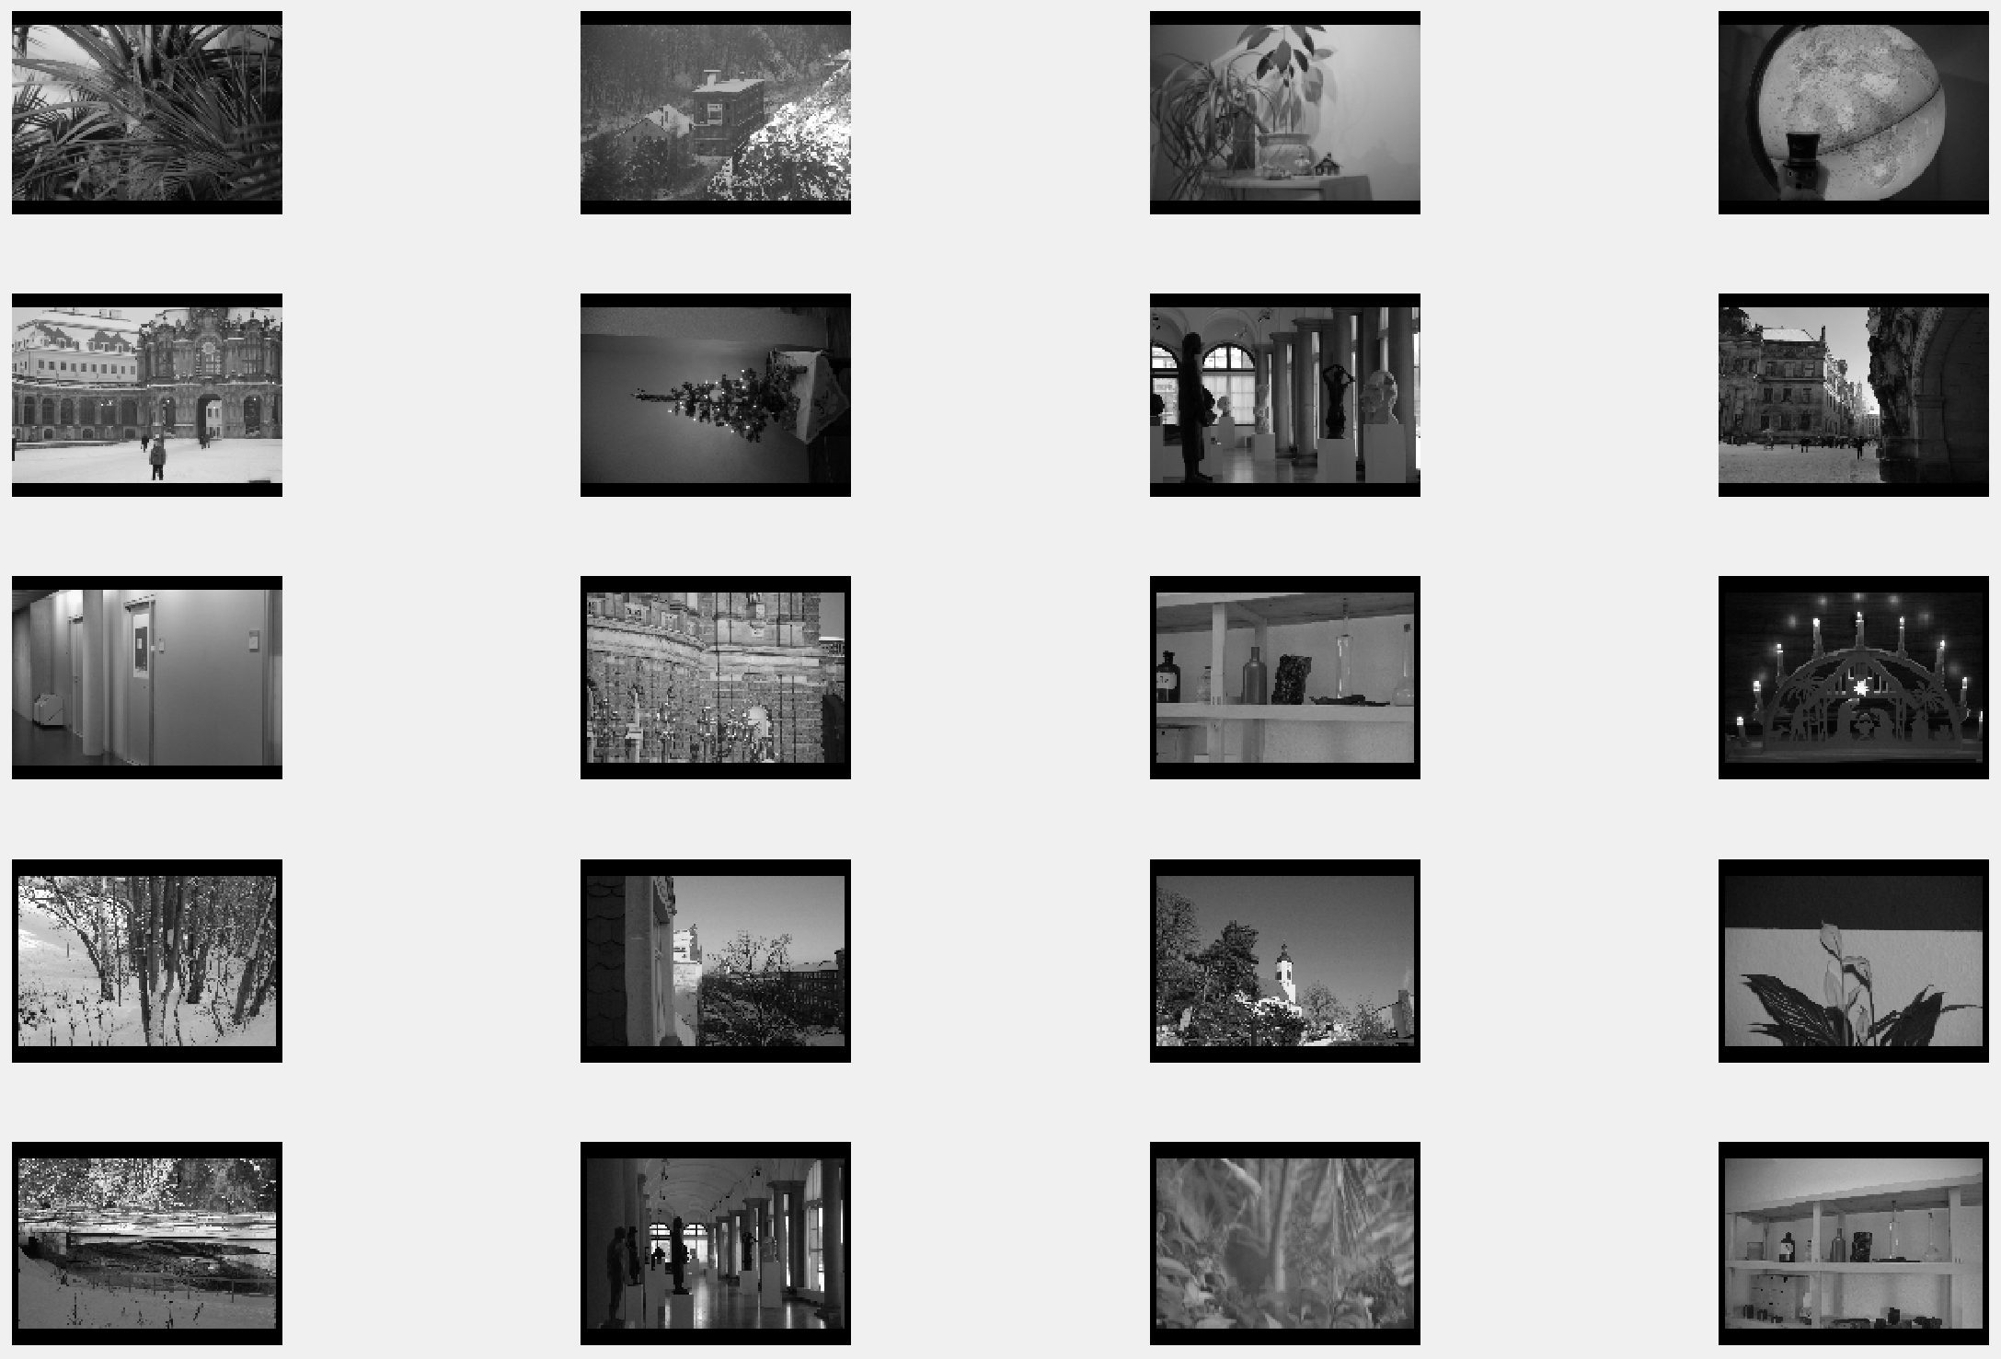

KLT with 20 coefficients on Set2:

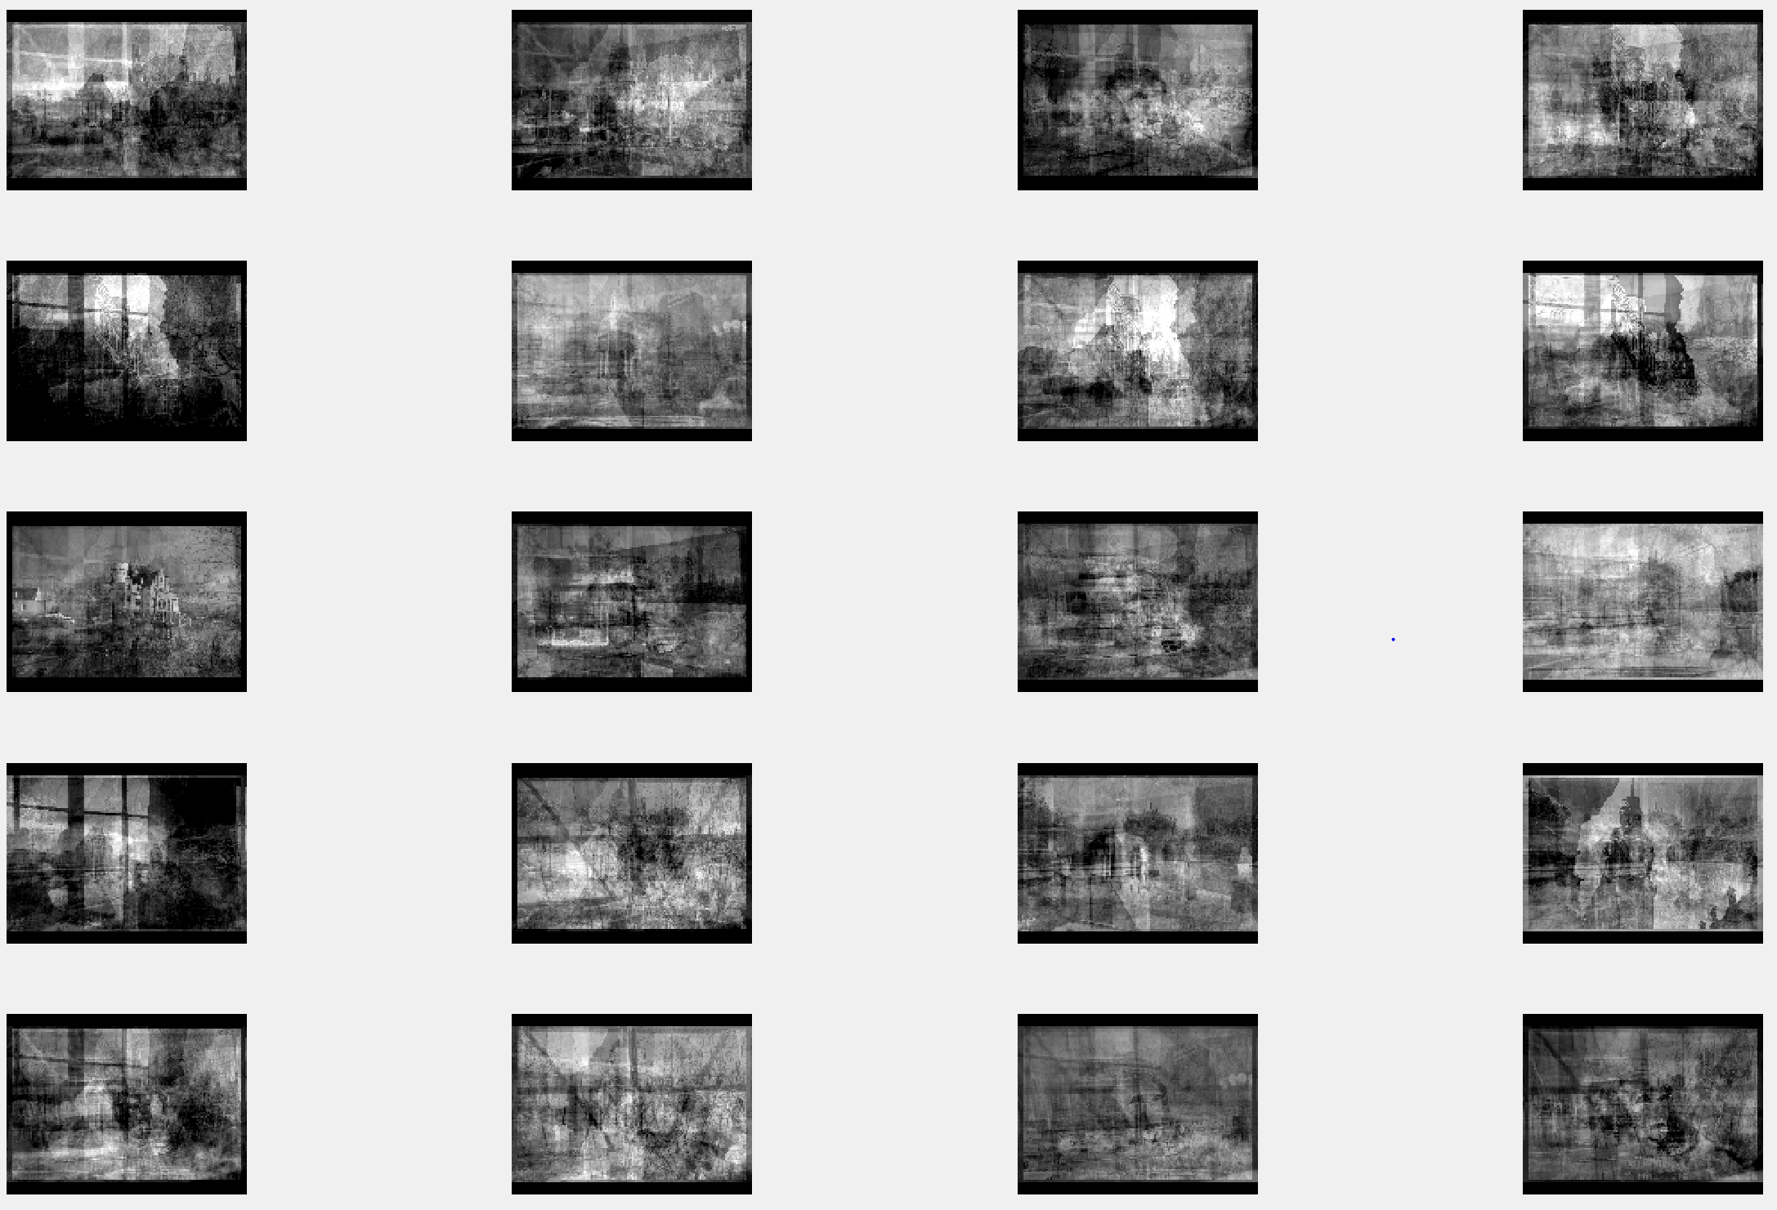

KLT with 100 coefficients on Set1:



KLT with 100 coefficients on Set2:



DFT with 5 coefficients on Set 1

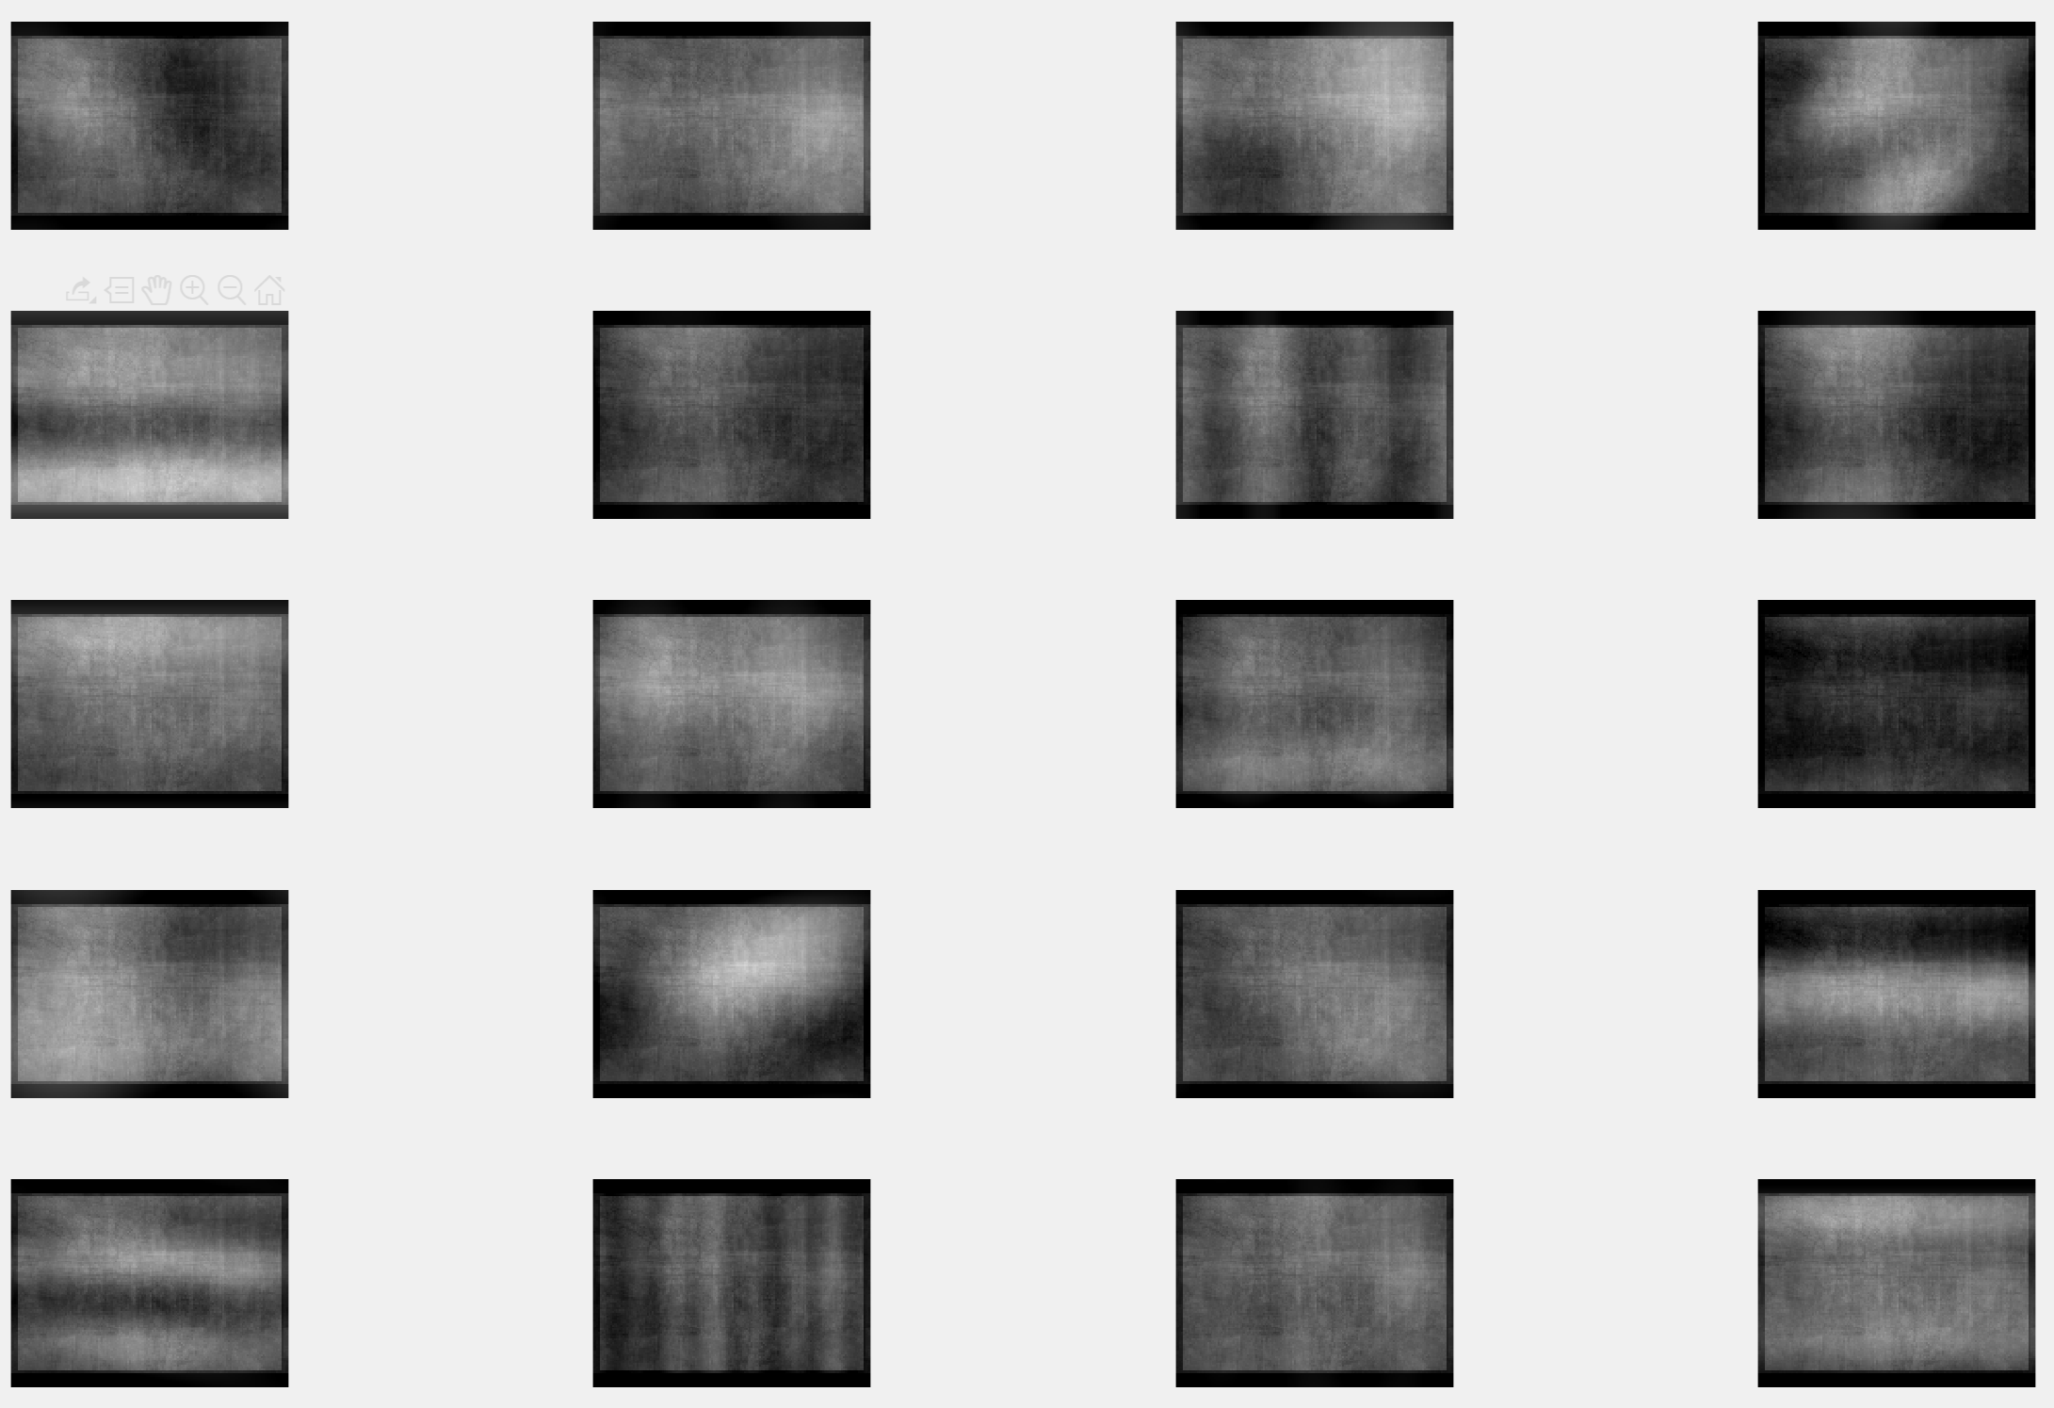

DFT with 5 coefficients on Set 2

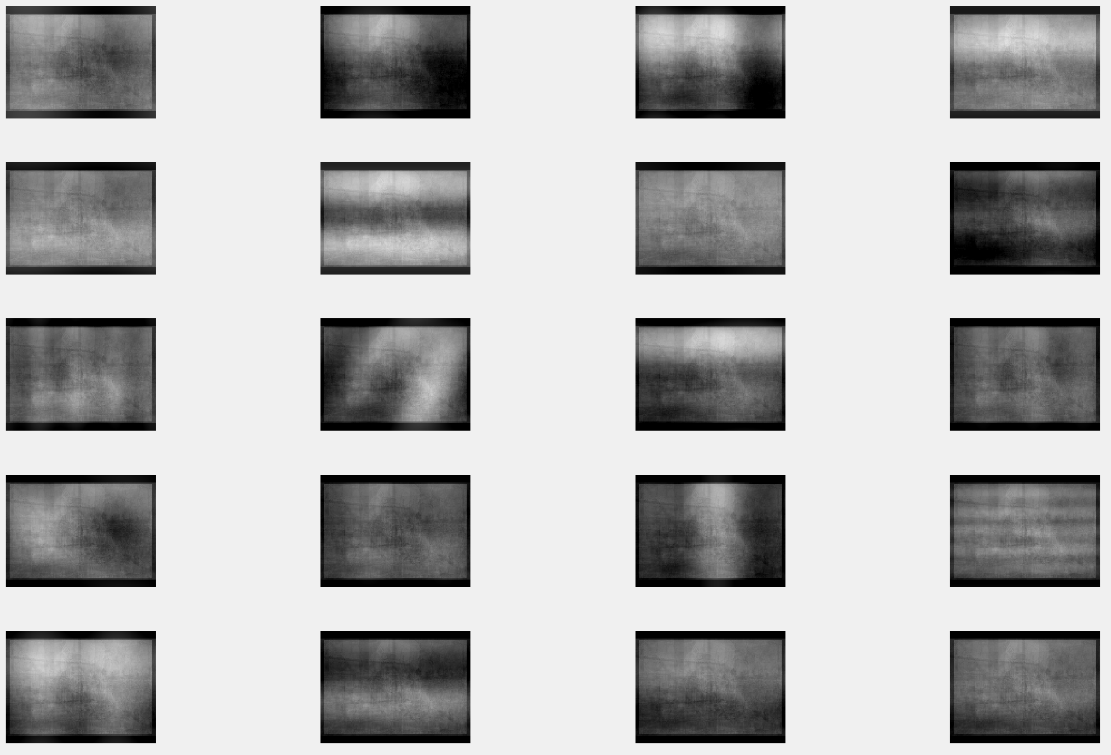

DFT with 10 coefficients on Set 1

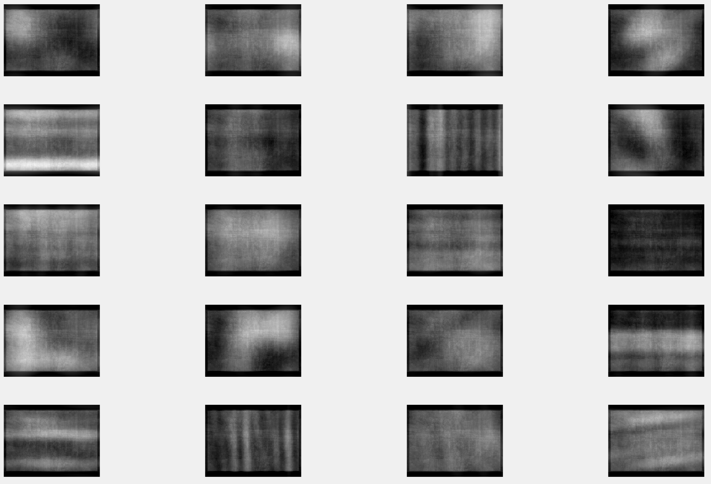

DFT with 10 coefficients on Set 2

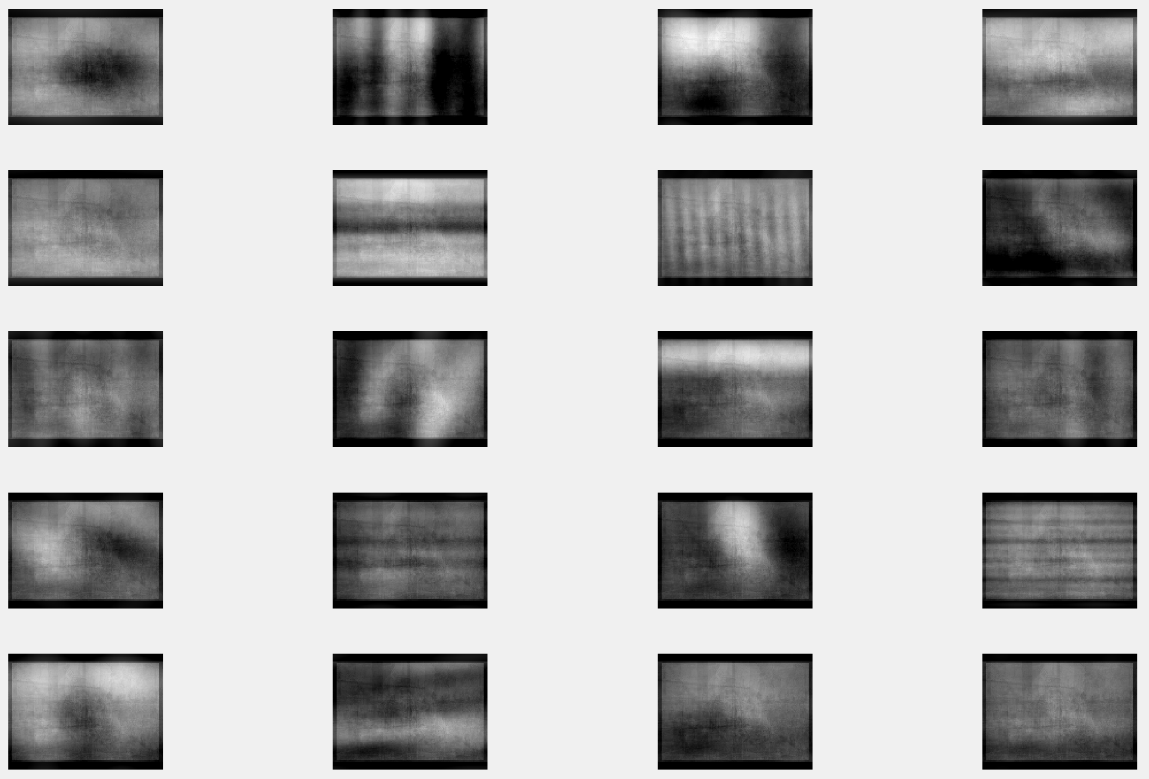

DFT with 20 coefficients on Set 1

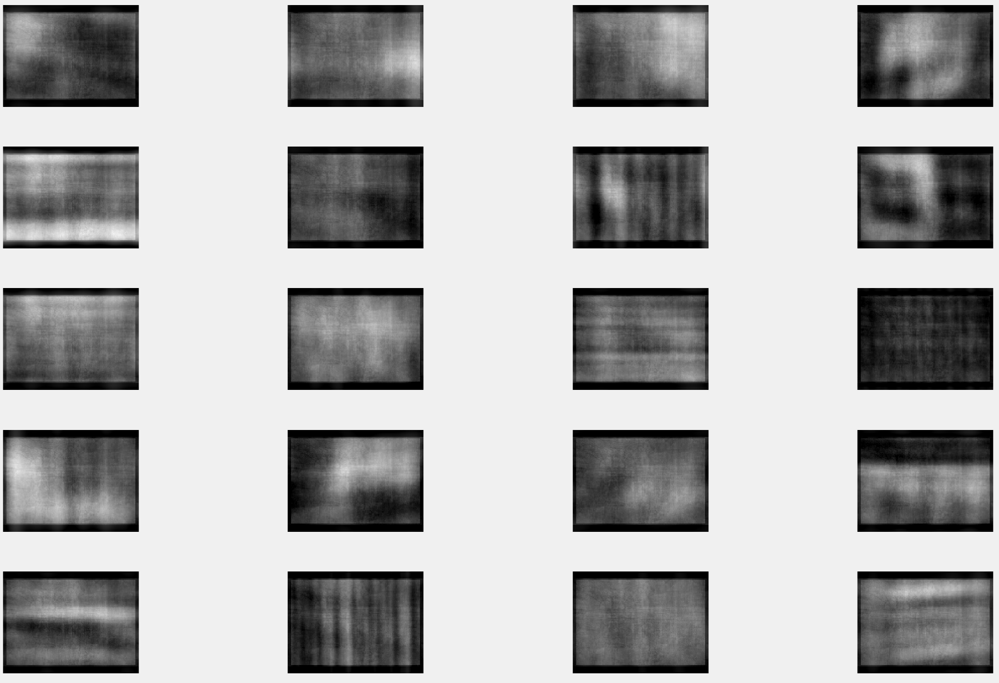

DFT with 20 coefficients on Set 2

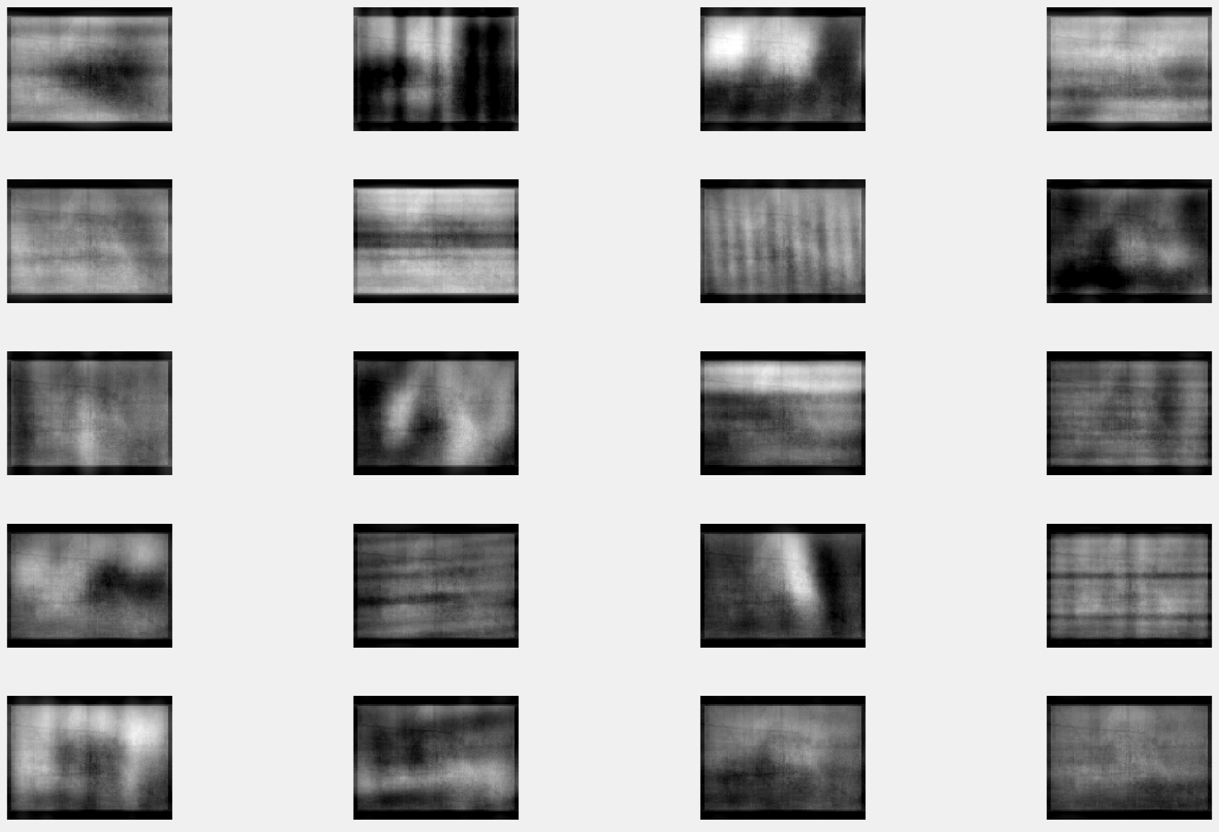

DFT with 100 coefficients on Set 1

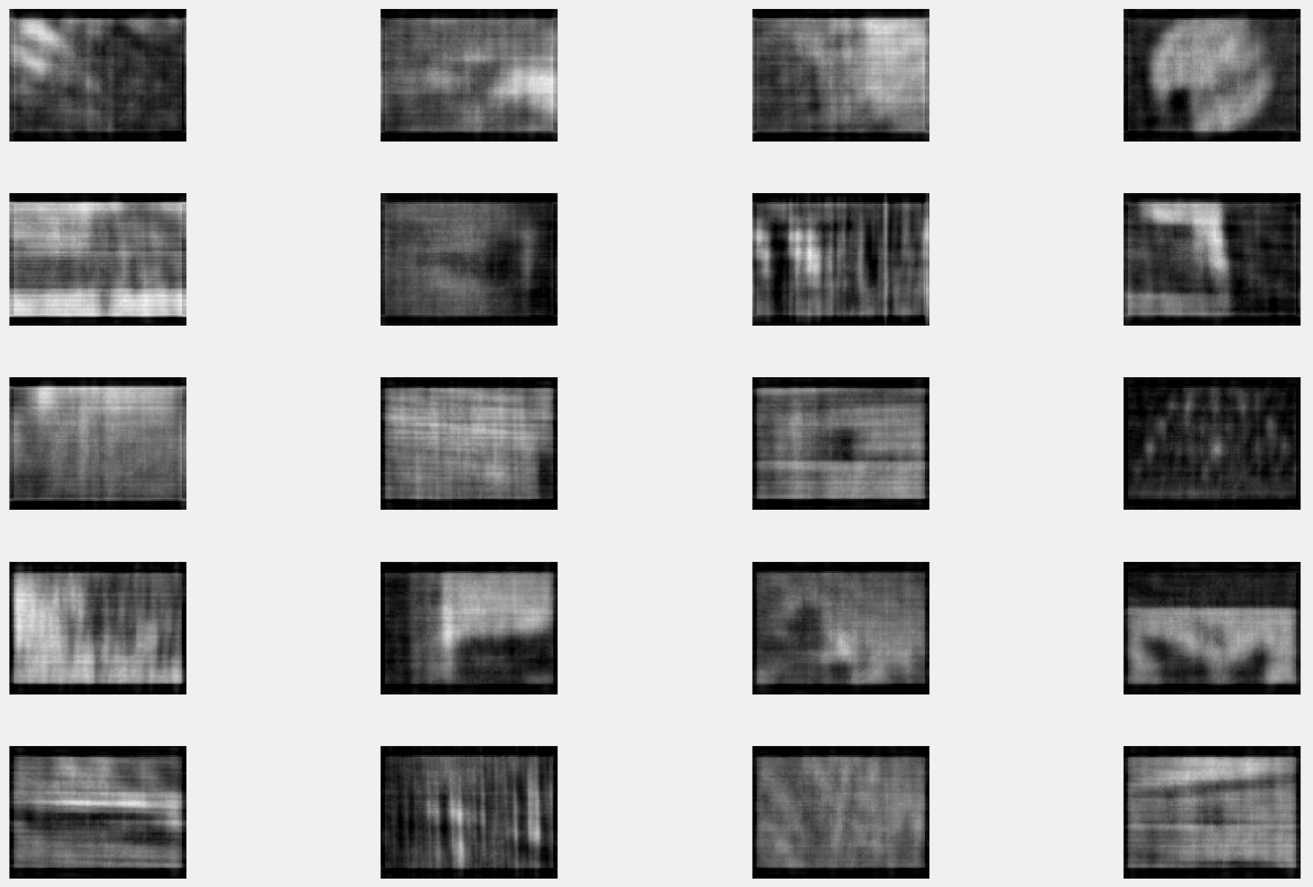

DFT with 100 coefficients on Set 2

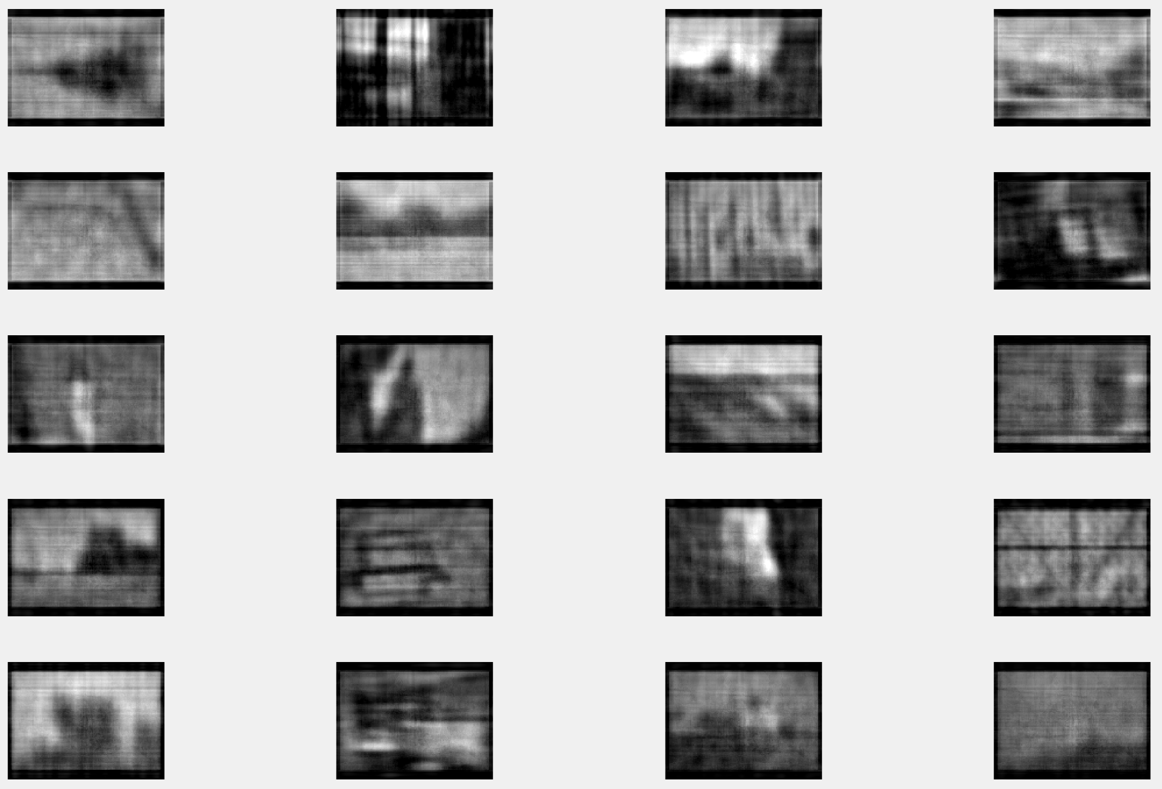

DCT with 5 coefficients on Set 1

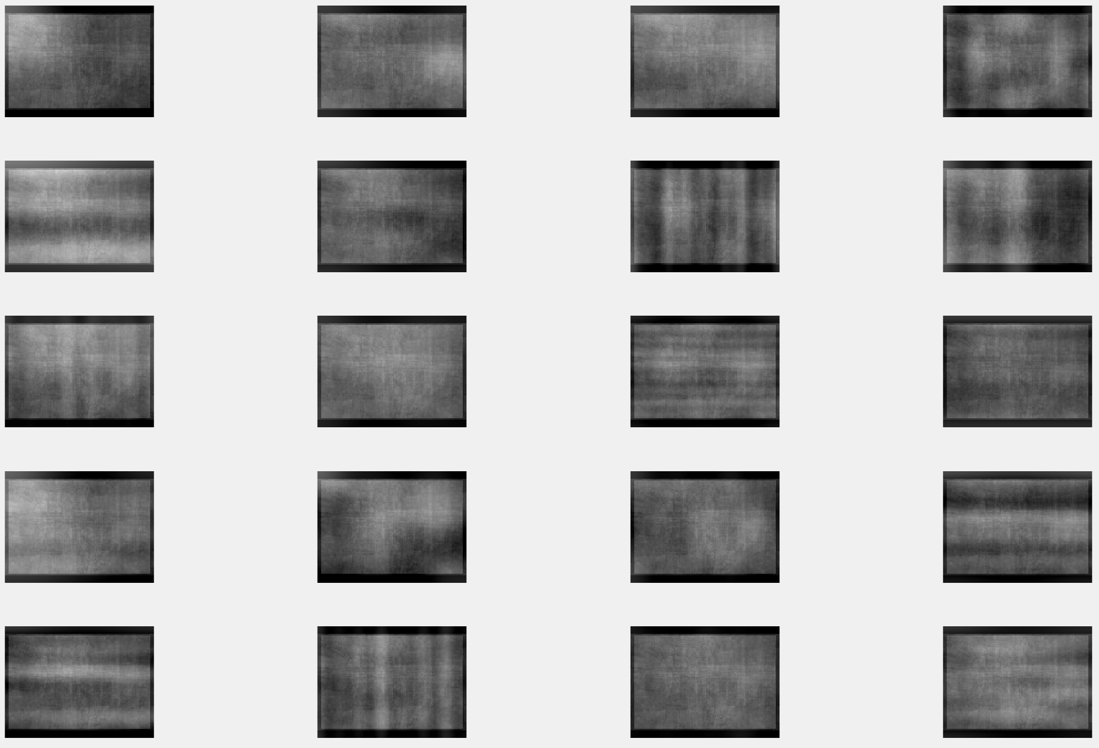

DCT with 5 coefficients on Set 2

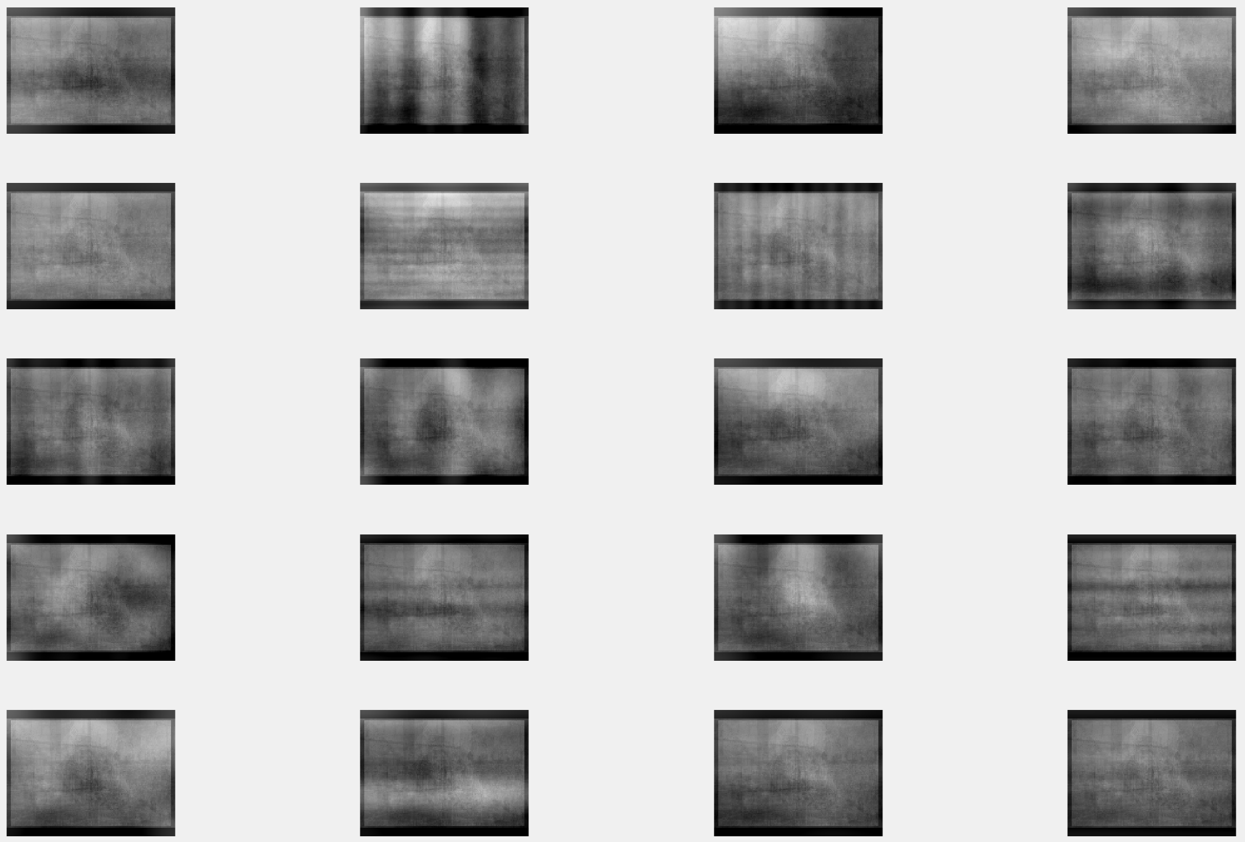

DCT with 10 coefficients on Set 1

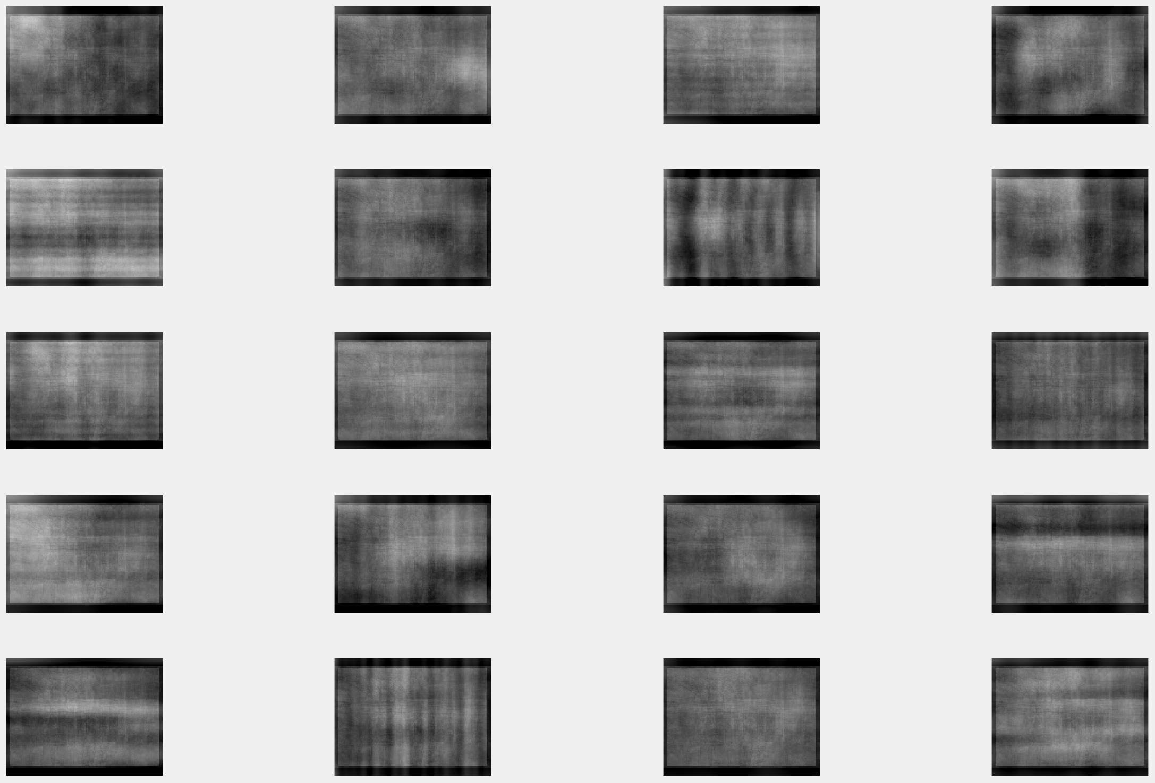

DCT with 10 coefficients on Set 2

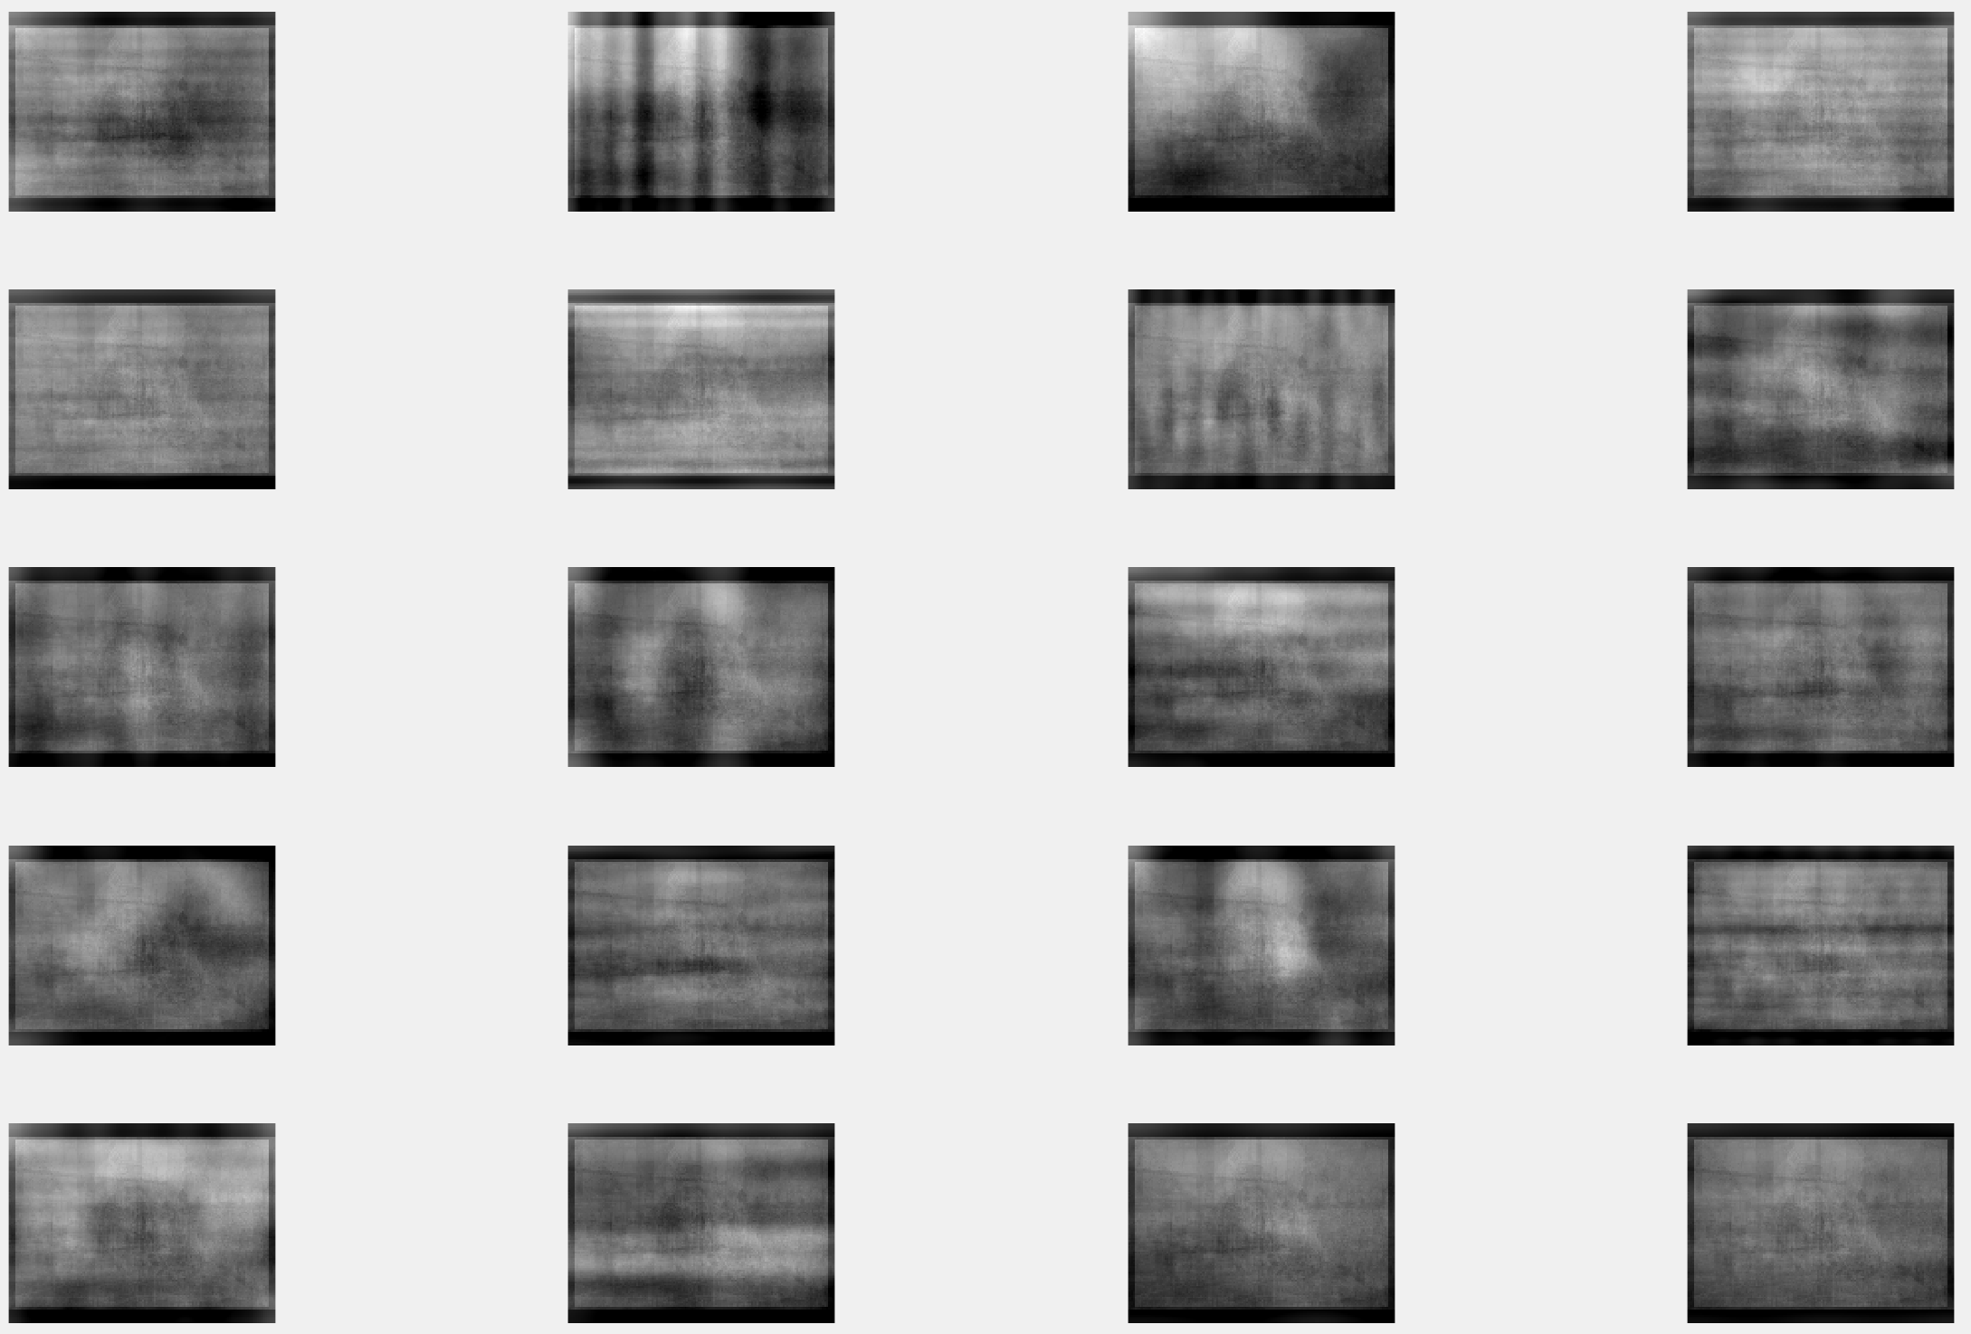

DCT with 20 coefficients on Set 1

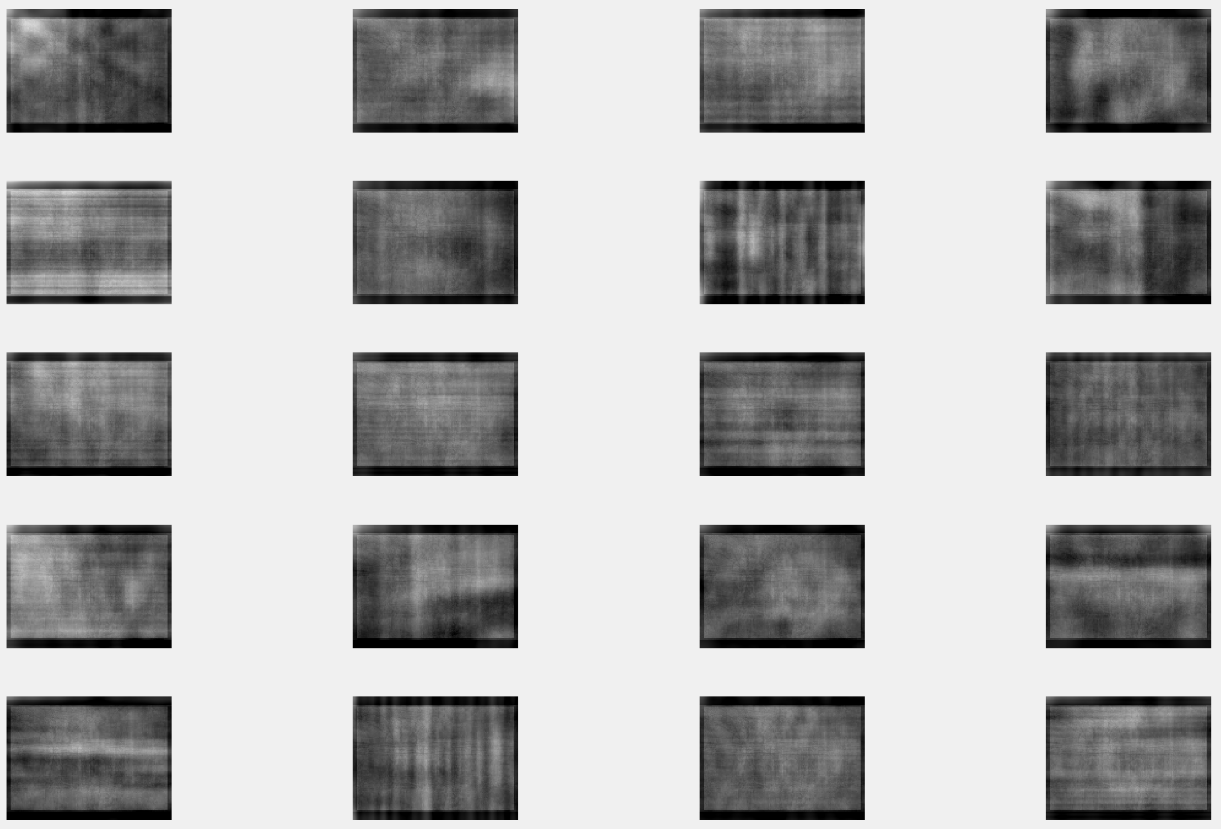

DCT with 20 coefficients on Set 2

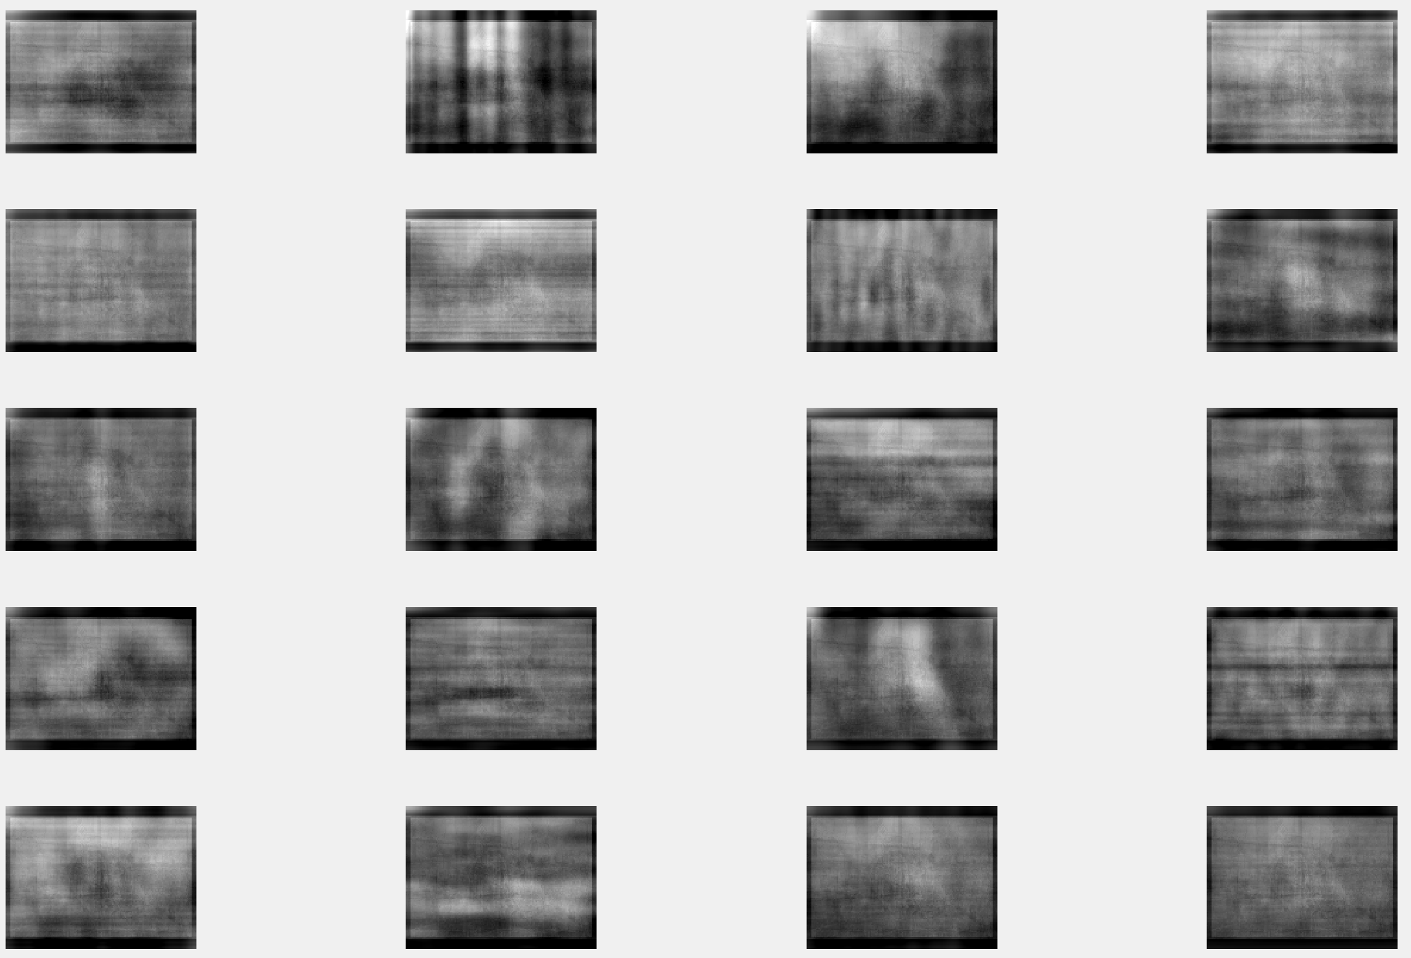

DCT with 100 coefficients on Set 1

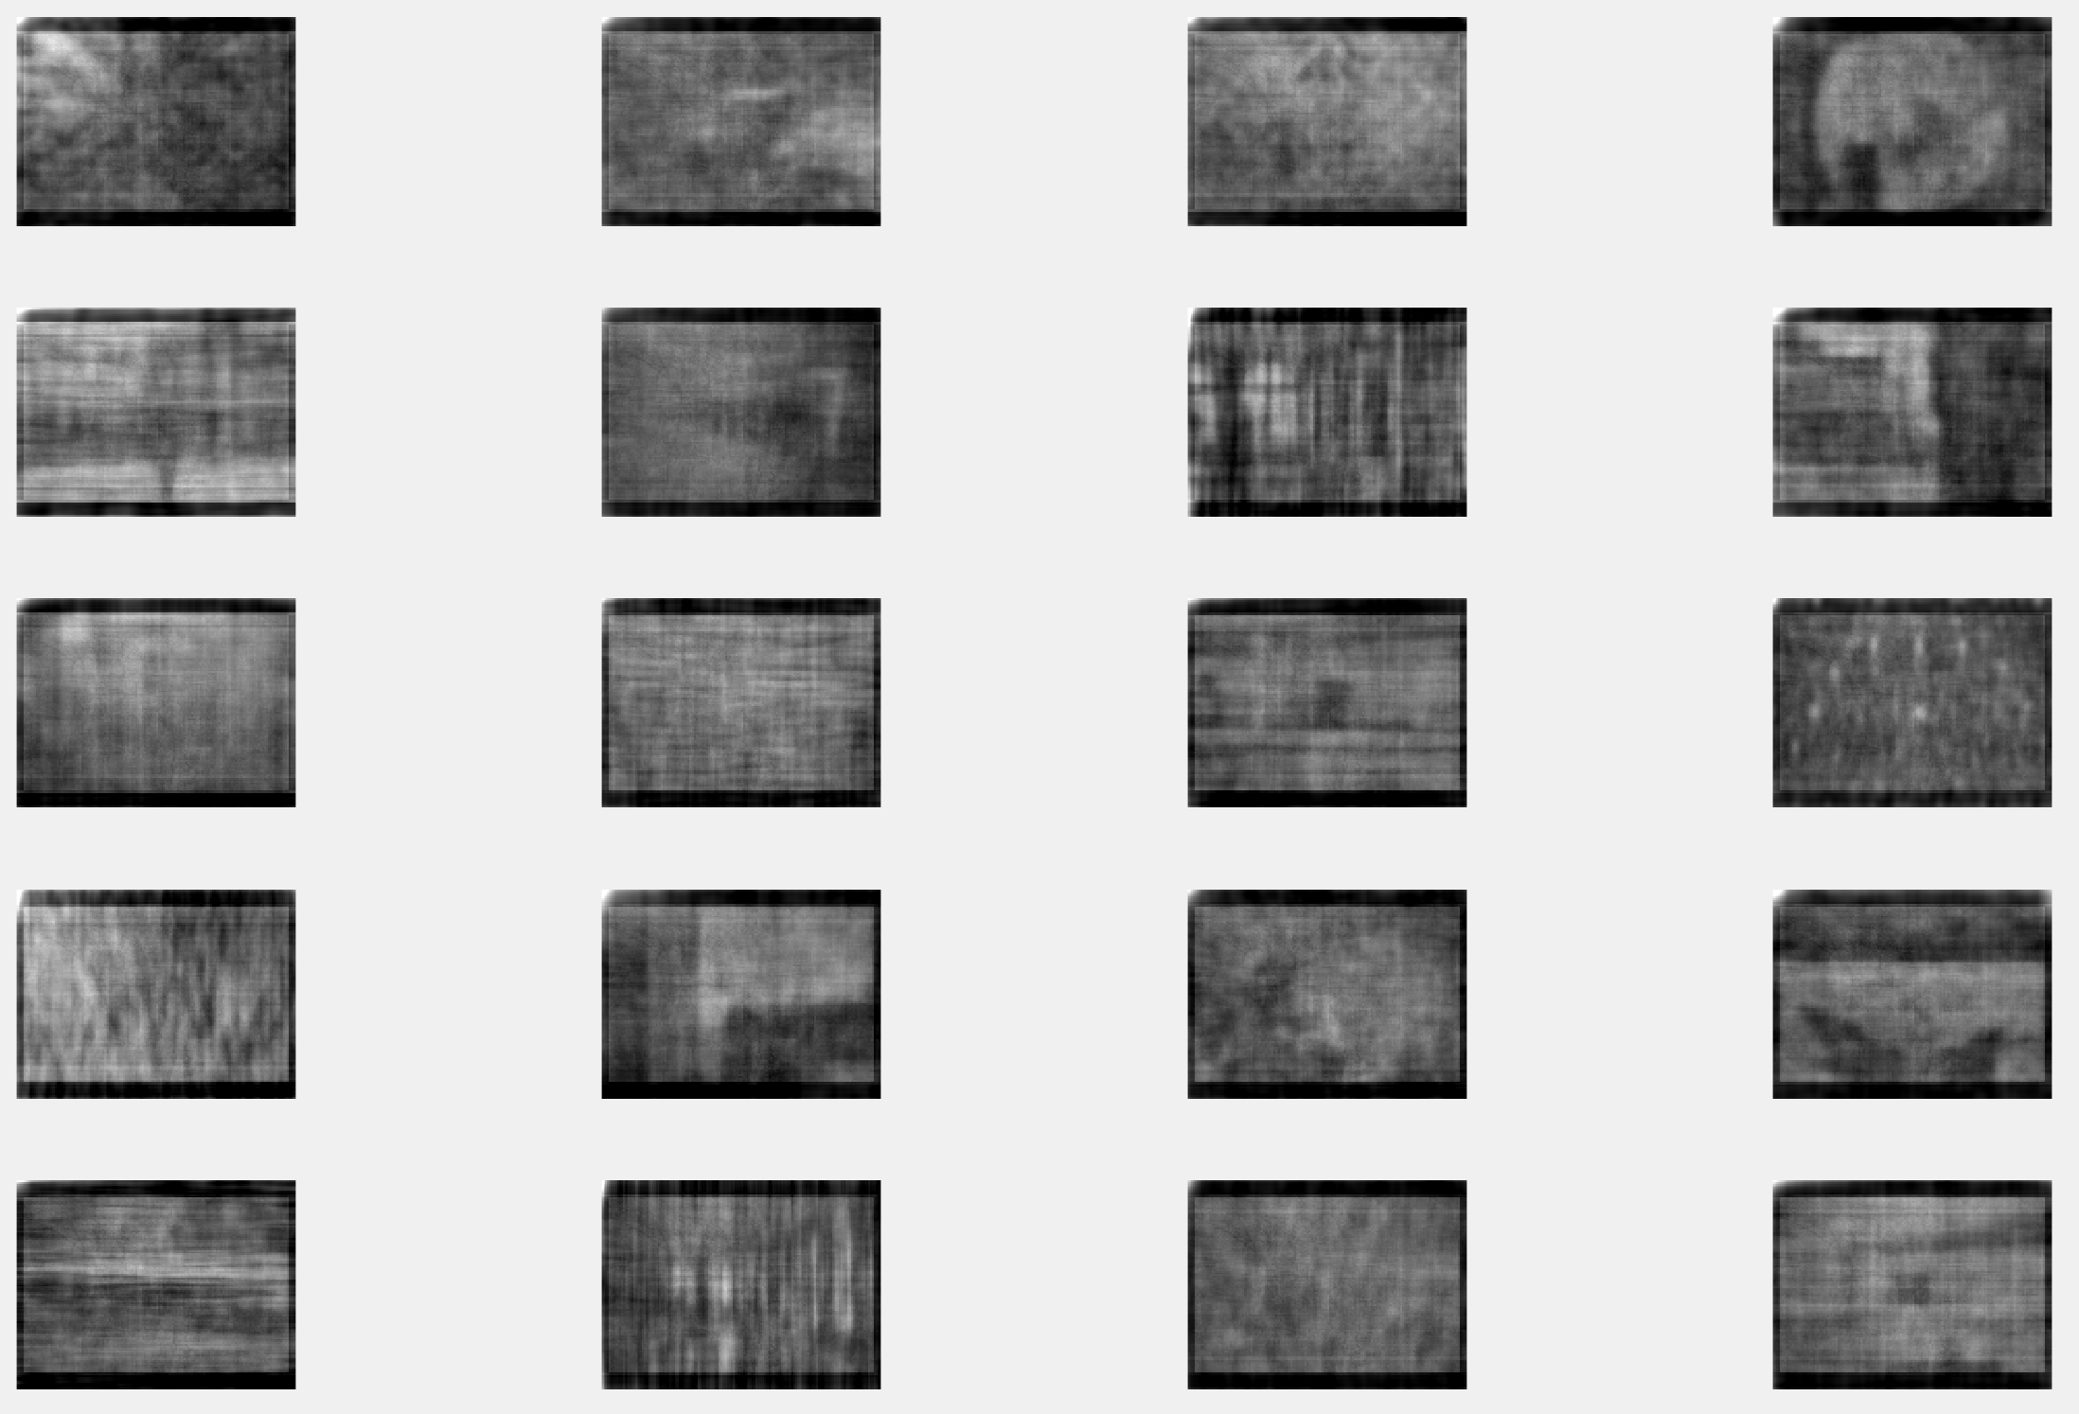

DCT with 100 coefficients on Set 2

